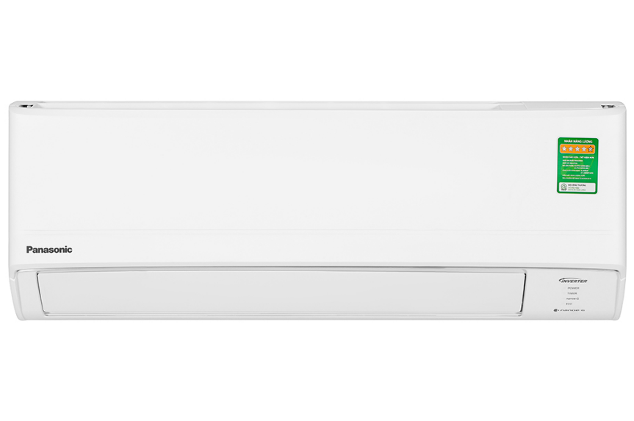

**13.240.000₫**

(-4%)

**Technical specifications Panasonic Inverter air conditioner 1.5 HP CU/CS-PU12ZKH-8M**

* Machine Type:

1 way (cooling only) With Inverter

* Cooling capacity:

1.5 HP - 11,900 BTU

* Effective cooling range:

From 15 - 20m² (from 40 to 60 m³)

* Dust filter, antibacterial, deodorant:

Nanoe-G filters PM 2.5 fine dust

* Power saving technology:

ECO integrates AI Inverter

* Rapid cooling:

Powerful

* Utilities:

Night sleep mode Sleep for the elderly and children Dehumidification function Self-diagnosis function Super quiet operation Quiet Turn on and off timer Automatically restarts when power is available

* Power consumption:

1.07 kW/h 5 stars (Energy efficiency 5.05)

* Cooler:

Length 77.9 cm - Height 29 cm - Thickness 20.9 cm - Weight 8 kg

* Outdoor:

Length 86.5 cm - Height 54.2 cm - Thickness 32.7 cm - Weight 22 kg

Introducing the company 

- Japanese brand.  
- Established in 1918. Panasonic entered the Vietnamese market very early, in the 1950s.  
- Panasonic is famous for its refrigerators, air conditioners, televisions and household appliances such as microwaves, fans, air conditioners. blender...  
- Panasonic products are famous for their high durability, energy saving, and beautiful designs.

[***Panasonic Inverter 1.5 HP CU/CS-PU12ZKH-8M air conditioner***](https://www.dienmayxanh.com/may-lanh/panasonic-inverter-15-hp-cu-cs-pu12zkh-8#2-gia)***provides an instantly cool space with Powerful fast cooling mode, smooth operation, limits power wastage with Inverter technology, ECO integrated with AI, Helps purify the air, keeping the room clean thanks to Nanoe-G technology, preventing damp rooms with dehumidification function.***

**Design overview**

**Cooler**

- Panasonic CU/CS-PU12ZKH-8M has a sophisticated, modern appearance, beautiful bright white tones, easily blends with different interior design styles. Horizontal rectangular design, compact size can be installed in narrow areas easily.

**Outdoor**

- Simple, sturdy structure, thick durable shell, impact-resistant and good resistance to harsh weather conditions, ensuring safety for the details inside the machine when you place the condenser in outside.

- [Inverter air conditioners](https://www.dienmayxanh.com/may-lanh?g=may-lanh-inverter)  use  **gas pipes made from copper, aluminum heatsinks**  provide good heat transfer, anti-corrosion, giving the device a long life.

**Refrigeration technology**

**- 1.5 HP** capacity   meets cooling needs in rooms with an area of ​​15 to 20m² (from 40 - 60m³).

[- Supports Powerful](https://www.dienmayxanh.com/kinh-nghiem-hay/cac-che-do-lam-lanh-nhanh-thuong-gap-tren-may-lanh-837183#powerful-panasonic) mode   so you can feel the coolness immediately thanks to the device increasing operating capacity, quickly lowering the room temperature.

**Air blowing mechanism**

[Panasonic air conditioners](https://www.dienmayxanh.com/may-lanh-panasonic)  operate with an  **automatic up and down** wind blowing mechanism that  helps spread cold air throughout the room so you can move, work, and entertain in a cool space.

**Power saving technology**

[- Inverter](https://www.dienmayxanh.com/kinh-nghiem-hay/the-nao-la-may-lanh-inverter-628934) technology   equipped with a powerful inverter compressor helps cool quickly, maintain stable temperature, durable use and optimally reduce power waste.

[- AI-integrated ECO](https://www.dienmayxanh.com/kinh-nghiem-hay/nhung-cong-nghe-noi-bat-tren-may-lanh-panasonic-1242950#eco-tich-hop-AI) mode   adjusts the power level and cooling time so that the room space is always cool, adjusting the appropriate power reduction level so you can both enjoy a cool space and save electricity. 20%.

- Energy label:  **5 stars** (energy efficiency 5.05), electricity consumption  **1.07 kW/h** .

**Air filtering ability**

**- Nanoe-G** technology   removes dust particles suspended in the air, including fine dust PM 2.5, giving everyone fresh air, extremely useful for people sensitive to dust.

*\*Images are for illustration purposes only*

**Utilities**

-  **Super Quiet operation** : when using this mode, [the air conditioner](https://www.dienmayxanh.com/may-lanh) will create a gentle airflow while operating smoothly, ensuring a quiet room space for your baby to sleep soundly and deeply.

-  **Dehumidifying function** : reduces humidity to keep the room airy and dry, limiting the possibility of items becoming moldy and making you feel more comfortable.

-  [Timer to turn the device on and off](https://www.dienmayxanh.com/kinh-nghiem-hay/cac-che-do-thuong-thay-tren-may-lanh-795107#hen-gio) : users can choose the usage time according to their needs, avoiding wasting electricity in case they go out and forget to turn off the device.

-  [Self-diagnosis function](https://www.dienmayxanh.com/kinh-nghiem-hay/cac-che-do-thuong-thay-tren-may-lanh-795107#doan-loi) : signals to the user when a problem arises in the machine so you can easily identify and find the right solution.

Besides, it is also equipped with Sleep mode for the elderly and children, and  [automatically restarts when there is power](https://www.dienmayxanh.com/kinh-nghiem-hay/cac-che-do-thuong-thay-tren-may-lanh-795107#tu-khoi-dong) .

*If you are looking for an air conditioner that saves electricity, has the ability to cool quickly, keeps the room space clean, reduces dust, has many convenient features, prolongs equipment durability, is suitable for you. Suitable for rooms of 15 - 20m², you should choose the Panasonic Inverter 1.5 HP CU/CS-PU12ZKH-8M air conditioner right away.*